**Australian Islamic College 2019**

**ATAR Chemistry Units 3 and 4**

**Task 10 (Weighting: 5%)**

**Term 3 Holiday Homework Validation Test**

**Proteins and Amino Acids**

Test Time: 45 minutes

Please do not turn this page until instructed to do so.

|  |  |
| --- | --- |
| **First Name** | **Surname** |
| **ANSWERS** |  |

|  |
| --- |
| **Teacher** |
|  |

|  |  |
| --- | --- |
| **Mark / 36** | **Percentage** |
|  |  |

Equipment allowed: Pens, pencils, erasers, whiteout, correction tape, rulers and non-programmable calculators permitted by the Schools Curriculum and Standards Authority.

**Special conditions**:

2 marks will be deducted for failing to write your full name on this test paper.

**Teacher help**: Your teacher can only help you during your test in one situation.

If you believe there is a mistake in a question show your teacher and your teacher will tell you if there is a mistake in the question and if appropriate, how to fix that mistake.

**Spelling of Science words** must be correct. Science words with more than one letter wrong (wrong letter and/or wrong place) will be marked wrong.

Unless stated otherwise, **equations** must be written balanced and with correct state symbols or they will be marked wrong.

Questions must be answered in this booklet.

Total marks: 36

**PART ONE: MULTIPLE CHOICE QUESTIONS (7 MARKS)**

**Circle the correct answer on this page.**

1. Insulin is a protein that acts as a hormone in the human body. It functions to control blood glucose levels. It consists of two separate chains of amino acids, the α chain and the β chain.

What level of structure is being maintained by the linkages between the two chains seen on the diagram?

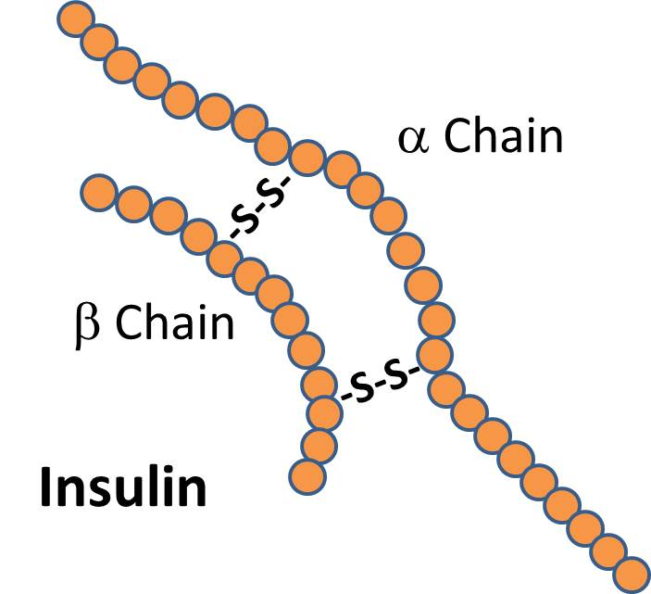

* 1. Primary
  2. Secondary
  3. Tertiary
  4. **Quaternary**

1. Which of these amino acids is more likely to be found in the core of a globular protein?
   1. **Alanine**
   2. Serine
   3. Tyrosine
   4. Glutamine
2. Which of these is not an alpha amino acid?
   1. **NH2CH2CH2COOH**
   2. NH2CH2COOH
   3. NH2CH(CH3)COOH
   4. NH2CH(CH2OH)COOH
3. Refer to the diagram below.

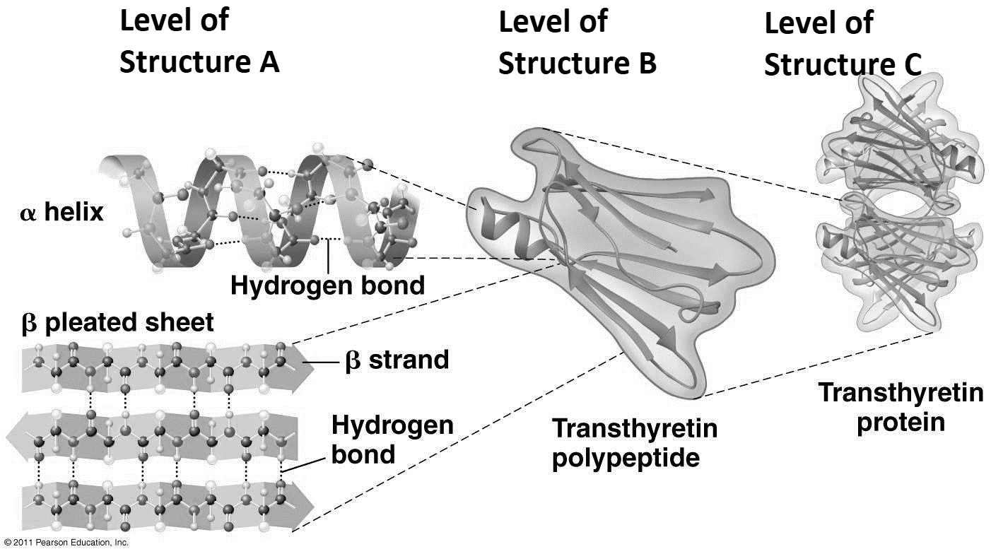

Which level of protein structure is ‘Level of Structure A’?

* 1. Primary
  2. **Secondary**
  3. Tertiary
  4. Quaternary

1. Which of these is a functional group found in all alpha amino acids?
   1. **Amine**
   2. Amide
   3. Ester
   4. Phenyl
2. Information about the three-dimensional structure of which of these groups of molecules is stored in the Protein Data Bank, in addition to information about proteins?
   1. Carbohydrates
   2. Lipids
   3. **Nucleic acids**
   4. Inorganic molecules
3. Which of these is not one or more chains of amino acids?
   1. Polyamides
   2. Proteins
   3. Polypeptides
   4. **Polynucleotides**

**END OF MULTIPLE CHOICE SECTION**

**PART TWO: SHORT ANSWER QUESTIONS (29 marks)**

1. Draw structural formulae of all the products resulting from the condensation reaction between three glycine residues.

(2 marks)

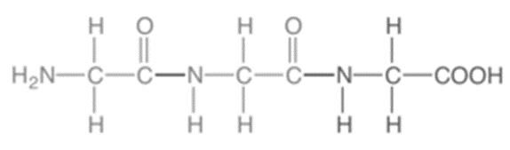 **(1) H2O (1)**

1. Tyroserleutide (YSL) is a tripeptide consisting of (in order) three amino acids, L-tyrosine, L-serine and L-leucine. YSL has exhibited potent antitumor activities in human tumour cell lines. Draw a structural formula for YSL, in unionised form, with the N-terminus on the left.

(2 marks)

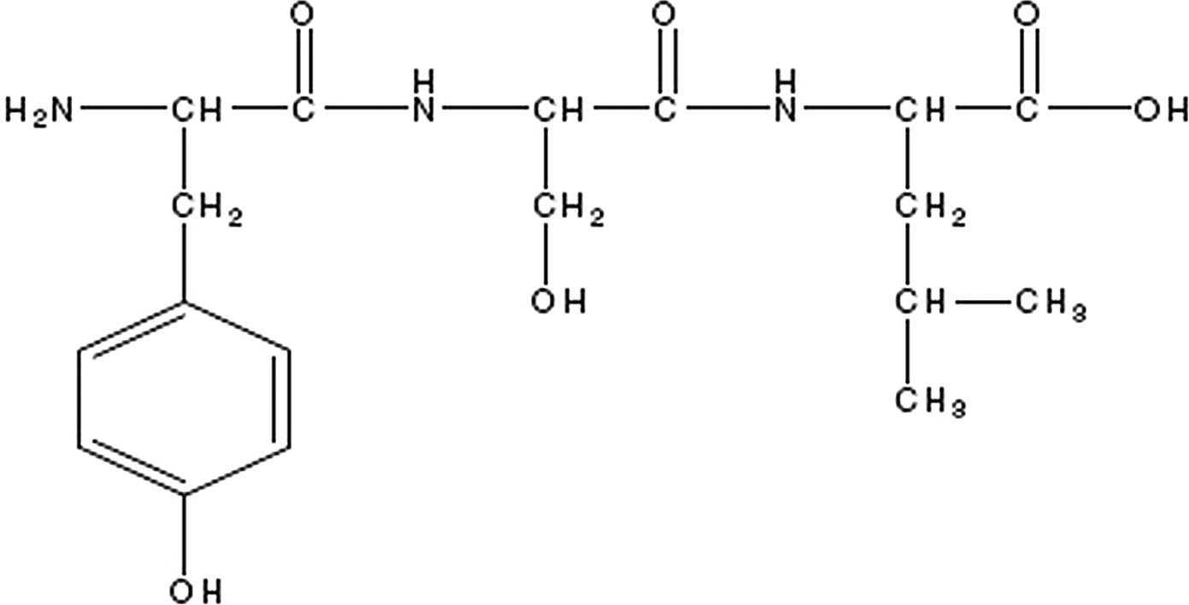

**1 mark off per mistake, including N-terminus not on left and not unionised.**

1. On the diagram below of a short polypeptide chain indicate exactly where a dilsulfide bridge could be found.

(1 mark)

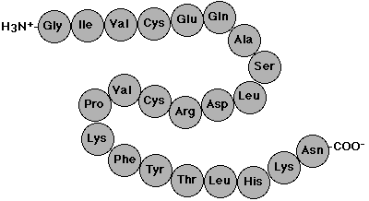

**Disulfide bridge should be shown ( -S-S-) connecting the two ‘cys’ residues.**

**No half marks.**

1. Below is shown the amino acid sequence of a short polypeptide.



* 1. Does the diagram represent the primary, secondary, tertiary or quaternary structure of the polypeptide?

(1 mark)

**Primary**

* 1. Draw the full structure of the amino acid closest to the C-terminus as a zwitterion.

(1 mark)

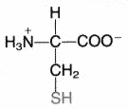

**No half marks.**

* 1. How many peptide bonds (peptide linkages) are shown in the diagram?

(1 mark)

**7**

* 1. Of the amino acids shown in the diagram, identify those that match the following descriptions. The same amino acid may be used for more than one answer and some amino acids may not be used.
     1. Four amino acids with side chains that cannot form any intermolecular forces other than dispersion forces.

(1 mark)

**Gly, Ala, Phe, Val. No half marks.**

* + 1. Two amino acids with side chains that are capable of hydrogen bonding but are not capable of forming salt bridges or disulfide bridges.

(1 mark)

**Ser, Tyr. No half marks.**

* + 1. An amino acid with a side chain capable of forming salt bridges.

(1 mark)

**Asp.**

1. The isoelectric point of tyrosine is 5.66. Draw a tyrosine molecule as it would exist at pH 6.00.

(1 mark)

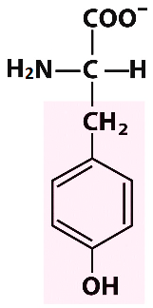

**No half marks**

1. Amino acids are covalent molecular substances. Whereas most covalent molecular substances with low molar masses have low melting points, amino acids are crystalline solids at room temperature.
   1. Explain why amino acids are solid at room temperature, despite being covalent molecular substances.

(3 marks)

**Amino acids exist a zwitterions (1) with both a positive and a negative charge (1). Ionic bonds form between opposite charges (1).**

* 1. Would you expect amino acids to be soluble in water? Explain why.

(2 marks)

**Yes (1). The positive and negative charges on the zwitterions would form ion-dipole forces of attraction with water molecules (1).**

1. Haemoglobin is the major protein found in red blood cells. It is a large protein consisting of four polypeptide chains. There are two chains called alpha chains and two chains called beta chains. Haemoglobin functions to carry oxygen from our lungs to the body’s cells.

The disease sickle cell anaemia results when the haemoglobin does not function correctly as a consequence of an incorrect primary structure in one of the beta chains.

Shown below is a short sequence of a normal beta chain on the left and the corresponding sequence in a person with sickle cell anaemia on the right.



* 1. State specifically what is wrong with the primary sequence of the beta chain in the person with sickle cell anaemia.

(1 mark)

**Glutamic acid / Glu has been replaced with valine / Val.**

* 1. Explain why the problem you referred to above is very unlikely to affect the secondary structure of haemoglobin.

(1 mark)

**Secondary structure does not depend on side chains / only the side chain has changed.**

* 1. By referring to the specific amino acids involved, propose an explanation why the haemoglobin of a person with sickle cell anaemia does not function properly.

(4 marks)

**The function of haemoglobin depends on its (secondary, tertiary and quaternary / three-dimensional) structure (1).**

**The glutamic acid /Glu is likely to be involved in salt bridges (accept ionic bonds) (1) that stabilise the (tertiary / quaternary) structure (1) of haemoglobin. The side chain of valine can only form dispersion forces (1). Without these the (tertiary /quaternary / three-dimensional) structure is changed / lost and therefore the function of haemoglobin is changed / lost (1).**

**Maximum 4 marks.**

* 1. Identify the amino acid that could most likely best replace glutamic acid without the symptoms of sickle cell anaemia appearing.

(1 mark)

**Aspartic acid / Asp.**

1. Ceviche is a method for preparing fish for eating that originated in Peru. Raw fish is soaked in an acidic solution prepared from citrus fruits. The low pH causes the fish proteins to be denatured.
   1. What does it mean that the proteins are ‘denatured’?

(1 mark)

**(A loss of function due to) a loss of secondary / tertiary / quaternary / three-dimensional structure.**

* 1. Name something other than a change in pH that can denature proteins.

(1 mark)

**Heat / high temperature / concentrated salt / organic solvent / radiation.**

**Not just ‘temperature’.**

**Any 1.**

* 1. By referring to specific amino acids, explain how low pH causes the protein to be denatured.

(3 marks)

**Low pH prevents the formation of salt bridges (accept ionic bonds) that stabilise tertiary / quaternary structure / three-dimensional shape (1) as COO- groups change to COOH (1) on aspartic acid / glutamic acid (either amino acid = 1).**

**END OF TEST**

**Blank Page For Student Use. This Page Will Not Be Marked.**